

Huawei RAN Connector

FRS (Functional Requirement Specifications)
Auto-Import connector

Change History

Version | Change Description | Author | Date
0.1 | First draft | Indrasan Yadav | 17-01-2025
0.2 | Added a rule on separate node type parsing for BTS, BSC, RNC, NodeB, eNodeB & SRAN in heading “Note-1” under section 1 marked with pink color | Indrasan Yadav | 21-01-2025
0.3 | Added a rule to parse “FModule” in board under section 1.1.3 marked with pink color | Indrasan Yadav | 21-01-2025
0.4 | Added a rule to parse antenna separately under csv radio antenna under section 1.2 marked with pink color | Indrasan Yadav | 21-01-2025
0.5 | Added a rule to parse node type SRAN Controller separately in XML/CSV in heading “Note-2” under section 1 marked with pink color | Indrasan Yadav | 21-01-2025
0.6 | Added a rule to parse only node and ignore the physical information (where blank information is found in dump) under section 1.1.1 marked with pink color | Indrasan Yadav | 21-01-2025
0.7 | Added a rule to parse site Id under section 2 marked with pink color | Indrasan Yadav | 21-01-2025
0.8 | Added a rule to Parse Node & It’s related Physical under section 3.1, 3.2 & 3.3 marked with pink color | Indrasan Yadav | 21-01-2025
Table of Contents
Introduction 3

1 RAN Nodes 5
1.1 RAN Physical configuration 8
1.1.1 Cabinet 8
1.1.2 Shelf 9
1.1.3 Boards 11
1.2 Antenna…………………………………………………………………………………………………………………………13
2. Site Id Parsing Rule……………………………………………………………………………………………………………14

3. Implement New Rule to Parse Node & It’s Physical……………………………………………………………………..16

3.1 Duplicate Node with Different Model………………………………………………………………………………………...16

3.2 Disregard Nodes with Duplicate Child Node………………………………………………………………………………..17

3.3 Disregards Node with NEType=MBTS………………………………………………………………………………………19

Introduction

- This FRS is intended for Huawei RAN Nodes extraction.
- It describes how to parse the sites, nodes and physical configuration.
- The dump files provided are of xml file per node.
- The folder location is to be précised later. All nodes are extracted from files “ATAE_U2000” folder (folder name could be modified)

- The files format is as follow:

RAN Nodes
- Only NEtype=”BSC6900GSM”, ”BSC6900UMTS”, "BSC6910GU", ”BSC6910GSM”, "BSC6910UMTS", “eNodeB”, “MBTS”, ”GSMBTS”, “NodeB”, “BTS”, “BTS3900”, “BTS5900”, “BTS59005G”, “DBS3900IBS”, “MICROBTS3900” are to be considered during parsing.

- NEtype=BSC6900GU or BSC6910GU then node should be created under SRAN Controller.

- NEType= “BTS3900”/ “MICROBTS3900”/ “BTS5900”/ “MBTS”/ “BTS59005G”/ “DBS3900IBS” then the node is a SRAN.
- NEType= “BTS”/ “GSMBTS” then the node is a BTS.
- NEType= “NodeB” and “eNodeB” then the node is NodeB and eNodeB respectively.
- NEType= “BSC6900GSM”/ “BSC6910GSM” then the node is a BSC.
- NEType= “BSC6900UMTS”/ “BSC6910UMTS” then the node is an RNC.

- The following attributes are defined at node level:

Attribute | Importance | Comment
NE ID | [Mandatory] | - =NE name.
NE Name | [Mandatory] | NE Name will be extracted from attribute “NEName=”” in individual dump.  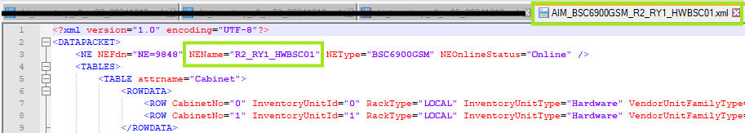
Site id | [Mandatory] | - Explained in the section 2
Site Name | [Mandatory] | - = Site id
Type | [Mandatory] | To be deduced from node matching file
Model | [Mondatory] | - The value of “NEType=” in node dump
Manufacturer | [Mondatory] | - = Huawei
IP + subnet mask | [Optional] | - =NULL
Technology Supported | [Optional] | - First, the Technology supported will be deduced as follow through matching the “NEType” within the below table:
  NEType | Technology Supported
  GSMBTS | 2G
  BSC6900GSM | 2G
  BSC6900UMTS | 3G
  BSC6900GU | 2G/3G
  BSC6910GSM | 2G
  BSC6910UMTS | 3G
  BSC6910GU | 2G/3G
  NodeB | 3G
  MBTS(GL) | 2G/4G
  MBTS(GU) | 2G/3G
  MBTS(UL) | 3G/4G
  MBTS(GUL) | 2G/3G/4G
  eNodeB | 4G
  BTS | 2G
  MBTSGU | 2G/3G
  BSC6000BTS | 2G
  BTS3900/BTS5900/BTS59005G | 2G/3G/4G
Parent BSC | [Mondatory] | - The node (BTS) with SiteName= which is available in that BSC dump under attribute <TABLE attrname="BTS"> then that BSC will be parent BSC for all available node (BTS).  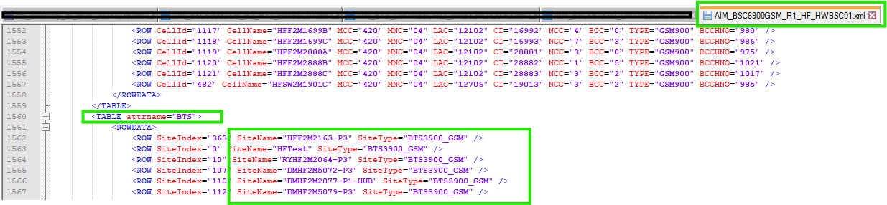  Note: same rule will be applied also for if parent will be SRAN Controller.
Parent RNC | [Monatory] | - The node (NodeB) with NodeBName= which is available in that RNC dump under attribute <TABLE attrname="UCELL"> then that RNC will be parent RNC for all available node (NodeB).  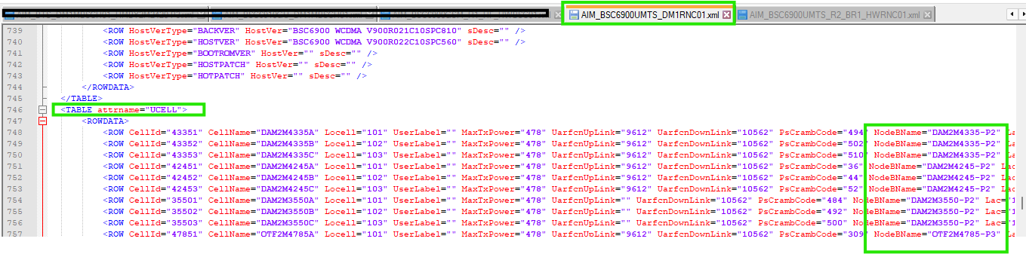  Note: same rule will be applied also for if parent will be SRAN Controller.
Software version | [Optional] | - =Null
Additional Information | [Optional] | - =Null

Note-1:

The existing/previous rule is retained with some modifications as outlined below:

- Node Parsing Update:

Earlier, there were parsing only three node types: BSC, RNC, and SRAN. We need to expand this to parse all possible node types separately, including BTS, BSC, RNC, NodeB, eNodeB, and SRAN.

This approach will follow the same methodology as we implemented for OmanTel.
The node type will be parsed based on the NEType= attribute as specified in the table below:

NEType | Node
BSC6900GSM | BSC
BSC6910GSM | BSC
BSC6910GU | BSC
BSC6900UMTS | RNC
BSC6910UMTS | RNC
NodeB | NodeB
eNodeB | eNodeB
GSMBTS | BTS
BTS | BTS
DBS3900IBS | BTS
MBTS | SRAN
BTS3900 | SRAN
BTS5900 | SRAN
MICROBTS3900 | SRAN
BTS59005G | SRAN

- Technology Confirmation:
The technology will be determined as follows:
  - BTS/BSC: 2G
  - NodeB/RNC: 3G
  - eNodeB: 4G

For SRAN, the technology may vary depending on the dump already available in the current connector. However, the following table will help define the technology:

Attributes | Technology
GbtsFunctionName= | 2G
NodeBFunctionName= | 3G
ENodeBFunctionName= | 4G
attrname="GCELL"> | 2G
attrname="UCELL"> | 3G
attrname="LCELL"> | 4G
attrname="NodeBCell"> | 3G
attrname="eNodeBCell"> | 4G
attrname="MBTS2GCell"> | 2G
attrname="MBTS3GCell"> | 3G
attrname="MBTS4GCell"> | 4G

Note-2:

In dump where we will get NEType=BSC6910GU, we will parse it as SRAN Controller node, as it is working like same of SRAN so there will be also 2G SRAN Controller & 3G SRAN Controller, where node id of 2G SRAN Controller & 3G SRAN Controller will be same as SRAN Controller node id.

Example:

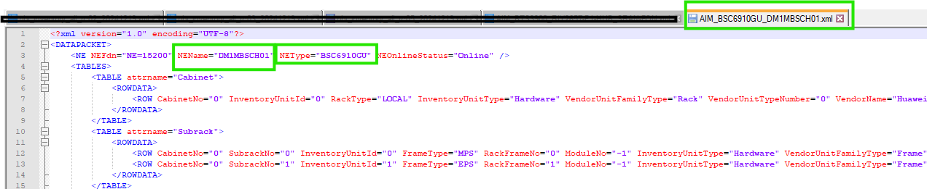

In above snippet we can see that there is NEType=BSC6910GU of node “DM1MBSCH01” which support technology G&U it means 2G & 3G both so we need to parse it as SRAN Controller.

RAN Physical configuration

Cabinet

- Each XML file of each node contains information about cabinets. From this file we will be taking the data for the cabinet.

- each type has one attribute <TABLE attrname="Cabinet"> for the cabinet’s info.

- The cabinet attributes are extracted as follow:

Attribute | Importance | Comments
NE External code | [Mandatory] | - Same as Node ID
Cabinet index | [Mandatory] | - The value of “CabinetNo” under attribute <TABLE attrname="Cabinet">  - Eg: CabinetNo="0" Cabinet index=0  - If “CabinetNo” is empty, then ignore the line.  - Sometimes we can get more than one cabinet. Parse all of them.  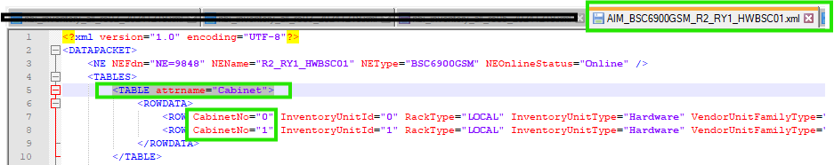  Note: If any node which contains blank physical (cabinet, shelf, board) information, then in that case only node will be parse & physical data (cabinet, shelf & boards & antenna) will be not parse.
Cabinet id | [Mandatory] | - = NE External code _cabinet index  - E.g.: R2_RY1_HWBSC01_0
Model | [Mandatory] | - The value of “RackType” attribute  - Eg: RackType="LOCAL" LOCAL  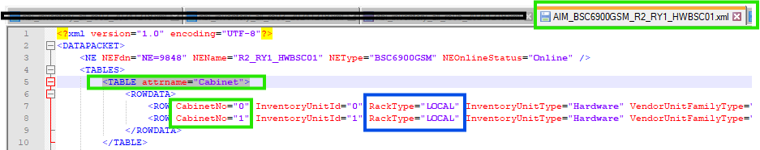
Part Number | [optional] | - =Value of “BOMCode” attribute  - Eg: BOMCode="01071087”
Date Of Manufacturer | [optional] | - =Value of “DateOfManufacture” attribute  - Eg: DateOfManufacture="2011-03-10" DateOfManufacture=2011-03-10
Description | [optional] | - =Value of “ManufacturerData” attribute  - If empty = null
Serial Number | [optional] | - =Value of “SerialNumber” attribute  - E.g.:SerialNumber="21010710876TB3000615
Manufacturer | [Mandatory] | - =Huawei
Power Consumption | [optional] | - =null
Additional Information | [optional] | - =null
Dimensions and Weight | [optional] | - =null

Shelf
- Each row under attribute <TABLE attrname="Subrack"> shows shelf information.

- The below table describes how to parse the shelf attributes:

Attribute | Importance | Comments
Cabinet Id | [Mondatory] | - = NE External code _cabinet index  - E.g.: R2_RY1_HWBSC01_0
Shelf Id | [Mandatory] | - Concatenation between NEName, “_” and CabinetNo=, “_” and SubrackNo in related row under attribute <TABLE attrname="Subrack">
Shelf index | [Mandatory] | - The value of “SubrackNo=” under attribute <TABLE attrname="Subrack">  - E.g.: SubrackNo="0" Shelf index=0  - If “SubrackNo” is empty, then ignore the line.  - Sometimes we can get more than one cabinet. Parse all of them.  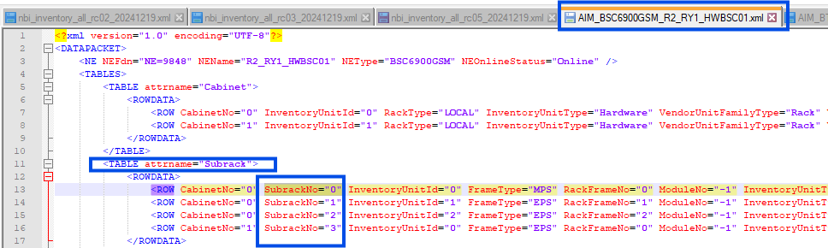
Part Number | [Optional] | - =Value of “BOMCode” attribute  - Eg: BOMCode="01071087”
Model | [Mandatory] | - =”FrameType” attribute , E.g.: MPS or EPS.  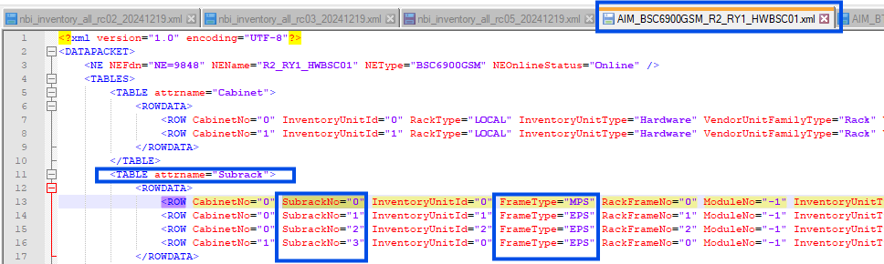
Date Of Manufacture | [Optional] | - =Value of “DateOfManufacture” attribute  - Eg: DateOfManufacture="2011-03-10" DateOfManufacture=2011-03-10
Issue Number | [Optional] | - Take the Value of “IssueNumber=” under same attribute <TABLE attrname="Subrack"> for related shelf.  - =Value of ”IssueNumber” attribute  Eg: IssueNumber="00”
Description | [Optional] | - =Value of “ManufacturerData” attribute  - If empty = null
Serial Number | [Optional] | - =Value of “SerialNumber” attribute  - E.g.:SerialNumber="21010710876TB3000615
Power Consumption | [Optional] | - Null
Additional Information | [Optional] | - Null
Dimensions and Weight | [Optional] | - Null

Boards
- Each row under attribute <TABLE attrname="Board"> shows boards information.
- The below table describes how to parse the boards attributes:

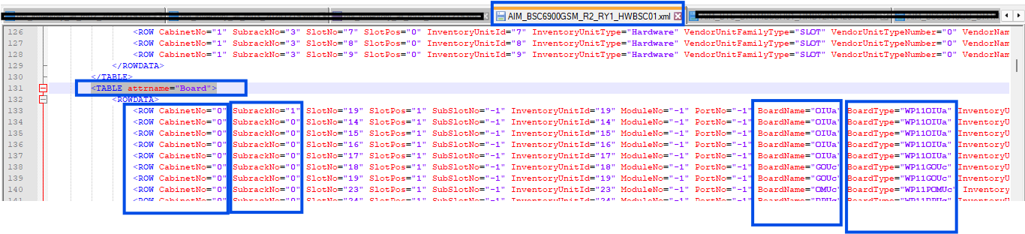

Attribute | Importance | Comments
Shelf Id | [Mandatory] | - Concatenation between NEName, “_”, RackNo,” _” and FrameNo
Shelf Index | [Mondatory] | - The value of “SubrackNo=” under attribute <TABLE attrname="Subrack">  - E.g.: SubrackNo="0" Shelf index=0  - If “SubrackNo” is empty, then ignore the line.  - Sometimes we can get more than one cabinet. Parse all of them.
Index on slot | [Mandatory] | =0 By default
Board Id | [Mondatory] | - Concatenation between NEName, “_”, “CabinetNo”, “_”, SubrackNo, ”_”, “SlotNo”.  - E.g.: R2_RY1_HWBSC01_0_1_19
Slot Index | [Mondatory] | - =Value of “SlotNo” attribute in each Row.
Board Type | [Mandatory] | Take the value of “BoardName=” under attribute “<TABLE attrname="Board">”  Note:  The existing rule can be retained with the following modification:  - We need to add BoardName="FModule" in the ‘npsboards’ section under the <TABLE attrname="Board"> class.  - Previously, the “FModule” board was not being parsed, but going forward, it should be parsed as boards with the required cabinet, shelf, slot, and board index as specified in the dump.  Sample Case:  The snippet below illustrates an example:  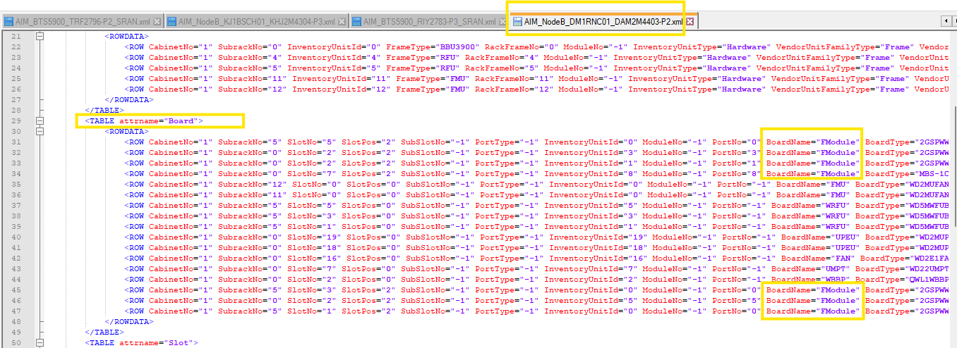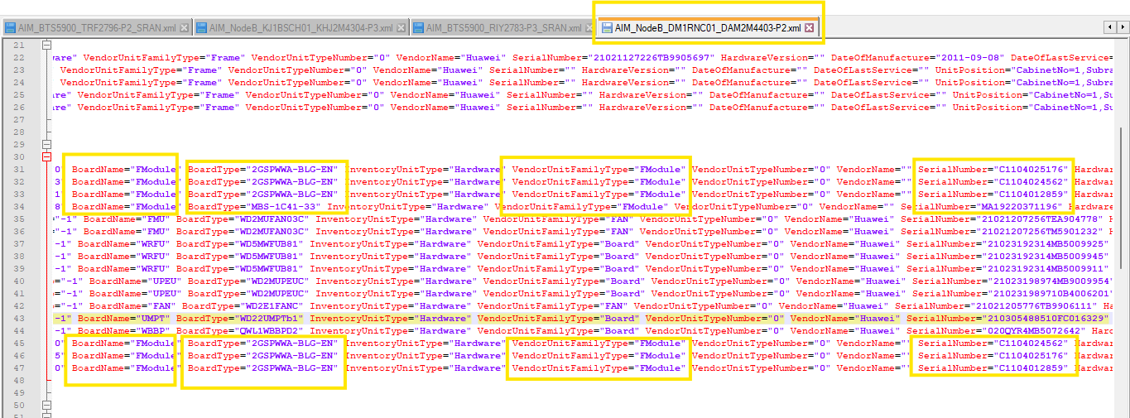  In this case, the “FModule” boards (count: 7) are present under cabinet-1 and are distributed across shelf-0 and shelf-5, occupying slots 7, 5, 3, 2, and 1.  All instances of “FModule” should be parsed in the XML as per the dump details.
Part Number | [Optional] | - =Value of “BOMCode” attribute  - E.g.: BOMCode="03051122" Part Number= 03051122
Description | [Optional] | =Value of “ManufacturerData” attribute  E.g.: ManufacturerData="PARC WP11OIUa 1-port channelized Optical Interface Unit REV:a" then description will be = "PARC WP11OIUa 1-port channelized Optical Interface Unit REV:a"
Date Of Manufacture | [Optional] | - =Value of “DateOfManufacture” attribute  Eg: DateOfManufacture="2011-05-07" DateOfManufacture=2011-05-07
Serial number | [Optional] | - =Value of “SerialNumber” attribute  E.g.: SerialNumber="210305112210B5000522" SerialNumber=210305112210B5000522
Issue Number | [Optional] | - =Value of “IssueNumber” attribute  Eg: IssueNumber="00" Issue Number=00
Power Consumption | [Optional] | - =null
Additional Information | [Optional] | - =null
Dimensions and Weight | [Optional] | - =null

Antenna Parsing

Antenna details will be parse under CSV of “radioantenna” in XML.

Antenna Parsing rule described below:

Attribute | Importance | Comments
Antenna Id/Object ID | [Mandatory] | - =Concatenate of “NEName=” and the value of “InventoryUnitId” (“InventoryUnitId” will be available under attribute <TABLE attrname="Antenna">
Name | [Mandatory] | - =Attribute “UnitPosition” take the value before the “,” indicator.  - Example: UnitPosition="AntennaDeviceName=RET_UMTS-A,AntennaDeviceNo=1" Name = RIY2657-P1-HUB_SRAN-FON_1,RET_UMTS-A.
RadioantennaType | [Mandatory] | - =attribute “AntennaDeviceType=”  - Example: AntennaDeviceType="RCU136" type =”RCU136”
VersionID | [Optional] | - Value of HardwareVersion, e.g if HardwareVersion="RF11CLPT_VER.D" then VersionId is RF11CLPT_VER.D
Band | [Optional] | - =attribute “ManufacturerData”
Sector | [Optional]

Additional information: Serial number will be parse under addinfo in XML.

Attribute | Importance | Comments
SerialNumber_<serialnumber> | [Optional] | - =Value of “SerialNumberEx” attribute  - Eg:SerialNumber="030LPM4MB5618639" SerialNumber=030LPM4MB5618639
SerialNumber_<serialnumber> |  | - Value of “SerialNumber” attribute  Eg:SerialNumber="030LPM4MB5618639" SerialNumber=030LPM4MB5618639

Site Id Parsing Rule

We will parse site id as described below:

Priority - 1:
- Extract the first string before any special characters (such as ‘-’, ‘_’, or ‘/’) from the node name.
- Search for this extracted value in column ‘C’ of the relevant tab in the “On Air Sheets V13” file, based on the node type (As described below). Retrieve the corresponding value from column “B,” which will be the site ID for the node.

Note: “On Air Sheets V13” will be provide by customer.

The steps for each node type are as follows:

A. For Node Type BTS:
- (I) Search first in the "2G Huawei" tab.
- (II) If not found, search in the "2G MMM" tab.
- (III) If still not found, search in the "On Air Summary" tab.
- (IV) If not found, search in the "Dismantled Sites" tab.
B. For Node Type NodeB:
- (I) Search first in the "3G Huawei" tab.
- (II) If not found, search in the "3G MMM" tab.
- (III) If still not found, search in the "On Air Summary" tab.
- (IV) If not found, search in the "Dismantled Sites" tab.
C. For Node Type eNodeB:
- (I) Search first in the "LTE Huawei" tab.
- (II) If not found, search in the "LTE MMM" tab.
- (III) If still not found, search in the "On Air Summary" tab.
- (IV) If not found, search in the "Dismantled Sites" tab.
D. For Node Type SRAN:
- (I) Search first in the "2G Huawei / 3G Huawei / LTE Huawei / 5G Huawei" tabs.
- (II) If not found, search in the "2G MMM / 3G MMM / LTE MMM / 5G MMM" tabs.
- (III) If still not found, search in the "On Air Summary" tab.
- (IV) If not found, search in the "Dismantled Sites" tab.

E. For Node Type BSC: Updated in the "site matching sheet."
F. For Node Type RNC: Updated in the "site matching sheet."
G. For Node Type SRANController: Updated in the "site matching sheet."

Priority - 2:
We will prioritize using the “Site matching sheet” for the site ID.

Priority - 3:
The existing rule should be followed for the site ID from the naming convention.

Example:

Consider the following node “MDN2U6996-P1-HRMCST” as an example, which is of the node type eNodeB.

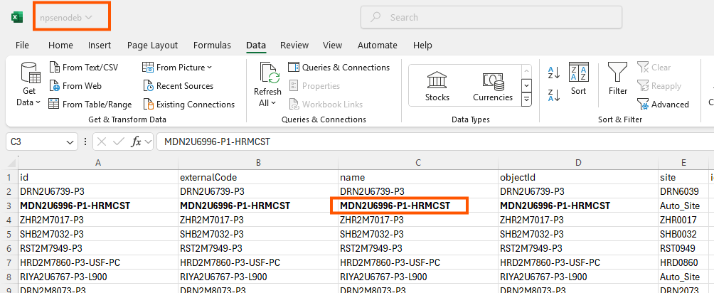

- Extract the first string from the node name before the special character ‘-’, i.e., MDN2U6996.
- Next, search for this value (MDN2U6996) in the sheet “On Air Sheets V13” under the tab LTE Huawei.
- The value corresponding to MDN2U6996 will be found in column ‘B’, which will be the site ID for the node “MDN2U6996-P1-HRMCST”. i.e., MDN6096 in this case.

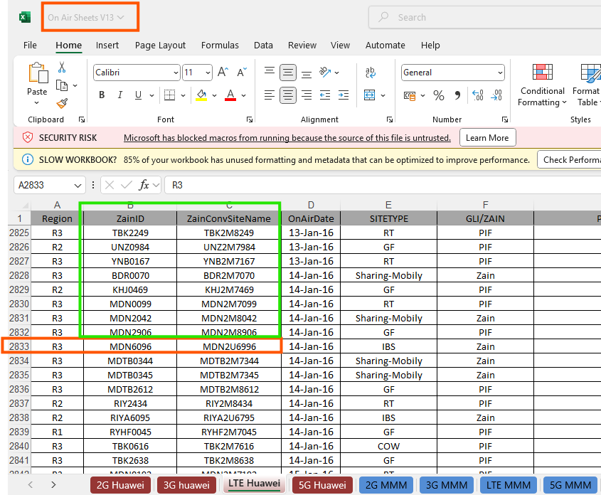

Implement New Rule to Parse Node & It’s Physical

We have implemented the following rule as confirmed by the customer, so we need to parse the node accordingly.

3.1. Duplicate Node with Different Model

Note: This rule will apply when the same node (NEName) appears with two different models. The first model will be "BTS5900" and the second one will be "BTS3900" (see example for reference).

Rule: We need to parse only the node that comes with NEType="BTS5900" and ignore the one with NEType="BTS3900".

Example: For the node (NEName="ARR0519-P1-HUB_SRAN-FON"), it appears in the dump with two different models: NEType="BTS5900" and NEType="BTS3900". We need to parse only the entry with NEType="BTS5900" and disregard the entry with NEType="BTS3900".

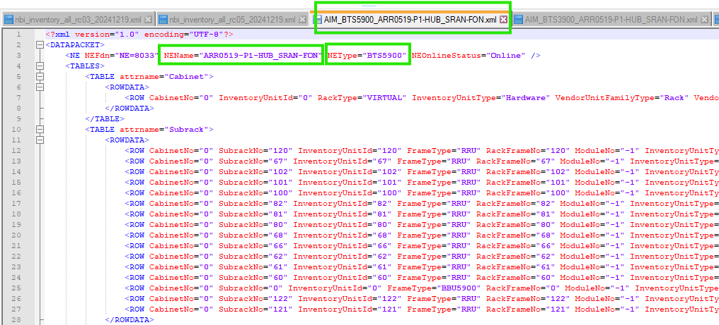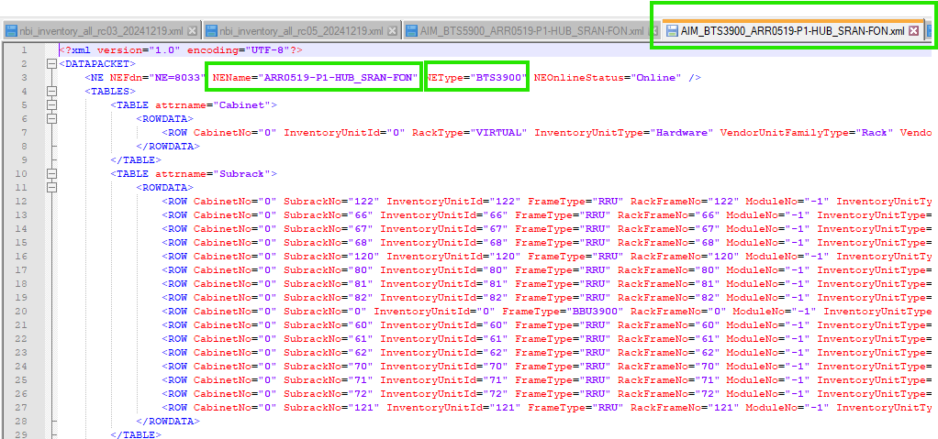

Disregard Nodes with Duplicate Child Node

Note: This rule will apply when duplicate child nodes (Role2G/Role3G/Role4G) are found across two different nodes (see example for reference).
Rule: We need to disregard the node containing “MMM,” “VIP,” “DIS,” “Core,” “FWA,” or “Templock” in the NEName, and parse only the second node.

Special Case:

Handle Duplicate Child Nodes for "MMM" and "VIP":

In cases where a duplicate child node is found across nodes with NEName containing "MMM" and "VIP," parse the node with "VIP" in the NEName and disregard the node with "MMM."

Example: Below are two examples where duplicate child nodes are found across two different nodes, and only one node will be parsed while the other will be ignored:

- The SRANB nodes MDN2996-P1-VIP_SRAN and MDN2996-MMM-P1-VIP_SRAN contain duplicate child nodes with the same model (NEType="BTS5900"). Both nodes have the same Role2G node, MDN2C2996-MMM-P1-VIP. In this case, we will parse only the node "MDN2996-P1-VIP_SRAN" and ignore the second node, "MDN2996-MMM-P1-VIP_SRAN," which contains "MMM" in the NEName.

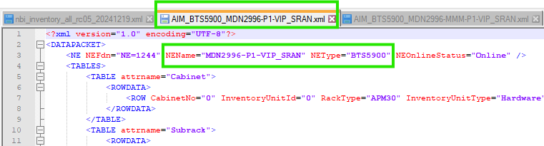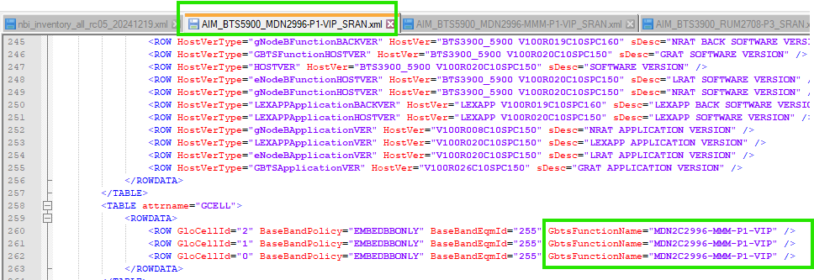

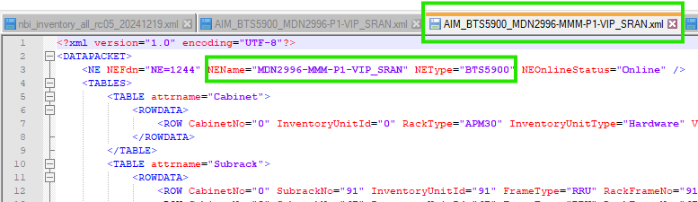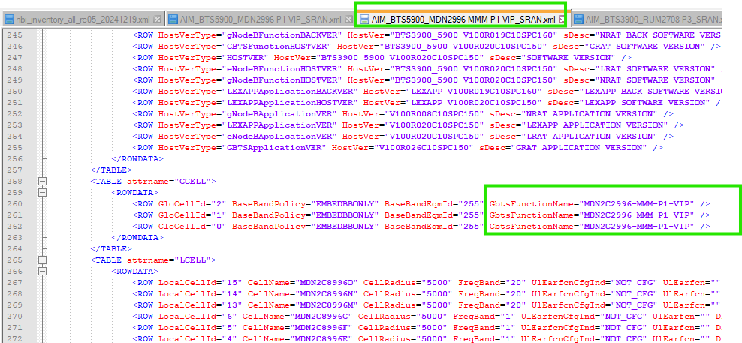

- The SRANB nodes RUM2708-P3_SRAN and RIY2708-VIP-P1_SRAN-DIS contain duplicate child nodes with the same model (NEType="BTS3900"). Both nodes have the same Role2G (RUM2M2708-P3), Role3G (RUM2M4708-P3), and Role4G (RUM2M8708-P3-L800) nodes. In this case, we will parse only the node "RUM2708-P3_SRAN" and ignore the second node, "RIY2708-VIP-P1_SRAN-DIS," which contains "DIS" in the NEName.

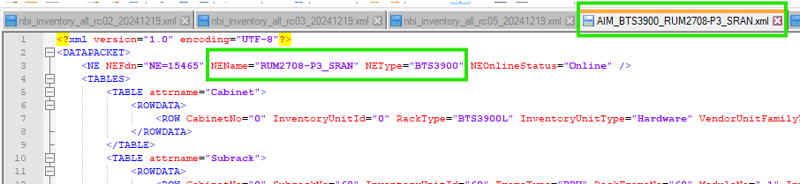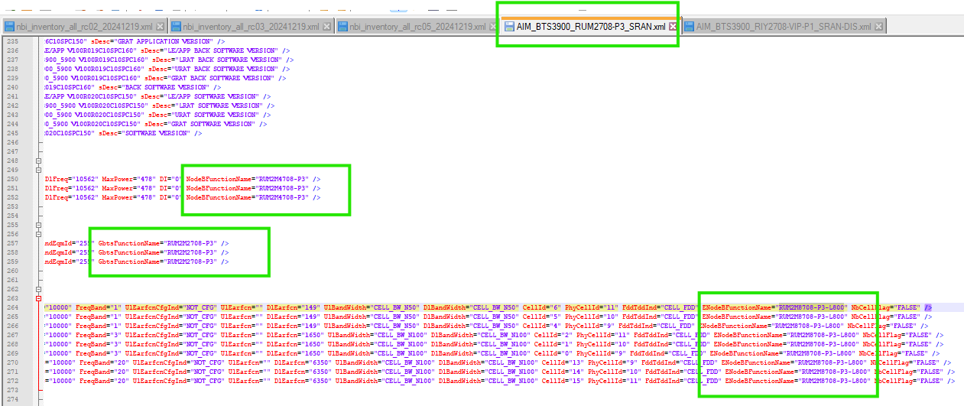

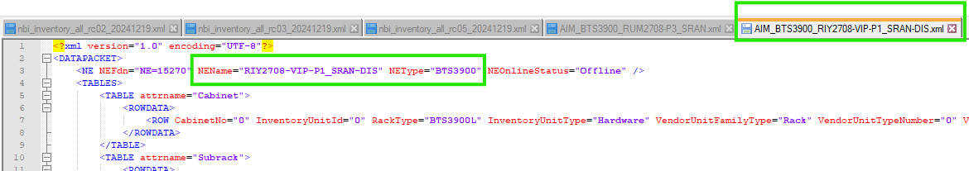

Disregard Node with NEType=MBTS

Note: This rule will apply to all nodes where NEType="MBTS" appears (see example for reference).
Rule: We need to disregard all nodes that appear in the dump with NEType="MBTS".

Example: Two examples of nodes where NEType="MBTS" is displayed are:

- NEName="MBTS-AFL0515-P2_SRAN"
- NEName="HFF0047"

